Emotional machines

Presentation held at V2_Lab workshop in Rotterdam, January 17, 2004

In my presentation, I will not dwell on psychological theories of emotion or on the importance of emotions for reasoning. I will instead point out some of the problems associated with the implementation of emotions into machines and outline some of the proposed solutions.

When we talk about emotional computers, we first have to differentiate between

- the recognition of emotions
- the simulation of emotions
- the generation of emotions and
- the expression of emotions

Furthermore, the recognition of emotions can be differentiated into

- the perception of emotions
- the identification of emotions and
- the interpretation of emotions

And if we look at the human observer of such machine actions, our point of interest is

- the recognition of emotions

a) The recognition of emotions

The recognition of emotions through machines is no trivial task. Why, it is difficult even for us humans! Individuals express their emotions quite differently: with different intensity (depending on individual dispositions and context dependencies), dependent on gender, and with different physiological parameters accompanying the emotion.

Picard lists some parameters which are important for the recognition of emotions. She groups them into two categories:

Apparent indicators are, i.e.,

- facial expression
- voice intonation
- gestures and movement
- posture
- pupilary dilation

Not (or less) apparent indicators are, i.e.,

- respiration
- heart rate and pulse
- temperature
- electrodermal response and perspiration
- muscle action potentials
- blood pressure

The first step would be to implement a perceptual system which can provide the machine with the necessary data. Parts of such a system would be cameras, microphones, and sensors to measure skin reactions, heart rate, blood pressure etc.

The problem with a lot of machine perception approaches is the inability to gather data from a moving object. People have to sit in a chair, their faces immobile; alternatively, they have to be equipped with clumsy measuring devices which impair their ability to act naturally.

To overcome these problems, Picard and her group at MIT are developing a number of measuring devices without these disadvantages. One of these devices are Scheirer’s “Expression Glasses” which measure facial muscle movement to identify emotions. Another is a specially equipped seat to measure changes in physiological reactions. The “TouchPhone” communicates the strength with which a phone is gripped by the user to the other participant in the form of different colours. Another device is a computer mouse which measures emotional states by the pressure exerted on it. Voice analysis can be used to detect the level of stress a speaker experiences.

Picard subsumes these techniques under the name the “concurrent-expression method”, as opposed to the “self-report” method in which the users have to indicate their emotional state actively. She points out that many people do not want their emotional reactions recorded which are not voluntarily controlled by them.

Paul Ekman has developed a system based on decades of research which identifies emotions by facial expression. His FACS (Facial Action Coding System) tracks the movement of facial muscles and correlates combinations of 44 “action units” to specific emotions. Currently, he is working on the implementation of FACS on a computer. A system equipped with cameras and the FACS database could then identify emotions within seconds.

Mourao and Paiva have developed EToy, a plush puppet equipped with sensors. The user manipulates the puppet in order to express a number of emotional states. The results of these movements are then interpreted and emotions are inferred based on the OCC model.

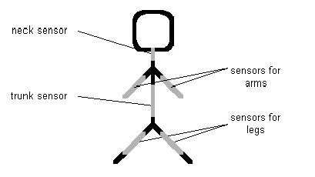

Gestures | Emotions
Put the toy's hands in front of it's eyes or moving the toy backwards vigorously | FEAR
Moving the toy slightly backwards (squeezing it slightly) | DISGUST
Swinging the toy (putting it dancing) and/or playing with its arms | HAPPY
Bend down its neck or bend down all the toy's trunk | SAD
To place its arms crosswise or shake the toy vigorously | ANGER
Open its arms backwards inclining its trunk slightly backwards too | SURPRISE

Even if it would be possible to collect all the above data, this would still not suffice to identify emotions exactly. Emotions are not person-independent, but always person-dependent; the machine would have to gather data of many individuals and, through a process of learning and pattern recognition, cluster these individuals into groups.

After the perception and identification of emotions comes the task of interpreting these emotions. Why is someone angry in a given context, why joyful? This is clearly dependent on the individual history of a person as well as the context of the situation. Both must be taken into account to generate an appropriate response to an emotion.
b) The simulation of emotions

The simulation of emotions has two aspects:

- the simulated emotions in the machine and
- the perceptions of these emotions by a human observer

This is a crucial distinction because humans tend to attribute qualities to people and objects which are not “really there”. An example are the Braitenberg “vehicles”, little mobile robots with a few simple embedded instructions. Observers labelled their behaviour as “aggressive” or “frustrated” although none of these “emotions” had been programmed into them.

There have been proposed different approaches to simulate emotions; I will briefly outline some of them. Most of these models are based on the emotion theory of Ortony, Clore and Collins (OCC model).

OCC define emotions as valenced reactions to events, agents or objects. These events, agents or objects are appraised according to an individual’s goals, standards and attitudes. The OCC model can be easily implemented in a rule-based system but has difficulties dealing with compound emotions which are not clearly defined.

Event, Agent, or Object
of appraisal
appraised in terms of
goals
(events)
norms/standards
(agents’ actions)
tastes/attitudes
(objects)
joy
distress

hope
fear

relief
disappointment

etc.

GOAL-BASED
EMOTIONS

anger
gratitude

gratification
remorse

etc.

COMPOUND
EMOTIONS

pride
shame

admiration
reproach

etc.

STANDARDS-BASED
EMOTIONS

love
hate

etc

ATTITUDE-BASED
EMOTIONS
Ortony (2002) has simplified the OCC model by collapsing some of the original categories down to five distinct positive and five negative specializations of two basic types of affective reactions–positive and negative ones. He believes that these categories have enough generative capacity to endow any affective agent with the potential for a rich and varied emotional life. Ortony, too, points out the importance of personality which determines the consistency of emotional reactions over time and makes an agent believable.

POSITIVE REACTIONS
… because something good happened (joy, happiness etc.)
… about the possibility of something good happening (hope)
… because a feared bad thing didn’t happen (relief)
… about a self-initiated praiseworthy act (pride, gratification)
… about an other-initiated praiseworthy act (gratitude, admiration)
… because one finds someone/thing appealing or attractive (love, like, etc.)

NEGATIVE REACTIONS
… because something bad happened (distress, sadness, etc.)
… about the possibility of something bad happening (fear, etc.)
… because a hoped-for good thing didn’t happen (disappointment)
… about a self-initiated blameworthy act (remorse, self-anger, shame, etc.)
… about an other-initiated blameworthy act (anger, reproach, etc.)
… because one finds someone/thing unappealing or unattractive (hate, dislike, etc.)
Table 1. Five specializations of generalized good and bad feelings (collapsed from Ortony et all., 1988). The first entry in each group of six is the undifferentiated (positive or negative) reaction. The remaining five entries are specializations (the first pair goal-based, the second standards-based, and the last taste-based).

Ortony further points out the importance of personality on emotions. They provide a character with consistency and coherence. This consistency and coherence can be observed in the reactions of a character. Ortony proposes the following emotional response taxonomy:

Bates and Reilly of the Oz Group at Carnegie-Mellon have created a virtual environment called TOK which contains the emotion module Em. Em contains 22 emotion types which are ordered hierarchically. They are based on the OCC model but have been simplified a bit in order to produce faster emotional reactions.

Since Oz is intentionally constructed as an artificial worl which is to be regarded by the user like a film or a play, it is sufficient to construct the various abilities of the system "flat" in order to satisfy expectations of the user. Because, as in the cinema, he does not expect a correct picture of reality, but an artificial world with in this context convincing participants.

Based on their work with Oz (which is not continued any more), Bates and Reilly have formed a company called “Zoesis” which produces lifelike computer characters based on their earlier research.

Clark Elliott has developed the Affective Reasoner, which is based on OCC as well. It contains a database of 24 emotion types, a data base of goals, standards and preferences (GSPs), a database of assumed GSPs for others (called COO – Concerns-of-Others by Elliott), and a database of reaction patterns. An agent continuously compares the patterns in the GSP and COO databases with so-called emotion eliciting conditions (EECs). If a correspondence is found, an EEC relation is created which then generates the appropriate emotion. In a further step, the emotion initiates an action. Elliott’s agents are capable of learning and of modifying the intensity of their emotions.

Once an emotion arises, agents have approximately 440 channels through which they can express these emotions: each emotion has approximately 20 of the channels. For example, anger might be expressed somatically as "turning red" at one end of the spectrum (not intentional), or by "invoking a plan to get even" at the other end of the spectrum (highly
intentional). In between we might find "verbal expression" (e.g., say something), "emotion repression" (deny that anything is wrong), and so forth. Channels are activated according to the temperament of the agent.

The agents are responsive in real time (e.g., when you talk with them, they respond immediately; if you don't say anything, they might get impatient). Agents have approximately 70 different facial expressions at their disposal. Their mouths move, and they control the speed with which they morph from one expression to another (also size and color of the face). Agents speak using text-to-speech technology. They can speek any sentence generated, in real time. Agents have limited ability to listen to spoken English, using speech recognition software. Agents have access to a, theoretically, almost unlimited amount of music to use to
express emotions. They can retrieve and play any music selection in less than a second, and the music can be indexed down to 1/1000th of a second. Agents select their own music to express their emotions, from pre-coded categories. Of special note is that we use a "minimalist" approach: the agents can run on a standard multimedia PC, and are effecient enough to be run over the Web through a standard modem (Web versions are only in very
early stages of development).

Agents can reason about the emotions that others are having about situations that arise; agents have relationships; agents have moods; agents keep models of how others see the world; etc.

One of the lines of research in the AR project which has yet to be developed to any depth, but which is promising enough to mention, is the idea of affective user modeling. In this paradigm the hard problems of general user modeling are left alone, with the focus being placed not on what the user knows, but how they feel. Since AR agents, and other emotionally-intelligent systems, necessarily keep at least implicit internal models of how others see the world (for how else can one, e.g., feel sorry for someone if not by knowing that they are sad about something?) it is not a big step to then model a user's general emotion state. In the AR agents this internal model is explicit, and it is only a minor theoretical leap to use this as a basis for tutoring, and other, goals. Bolstering this approach is something we have observed ad hoc in the relationship between users and AR agents, but which is also commonsensical: people are socially motivated to express their emotion states (e.g., I am frustrated, I am angry, I admire the way you...) even to a computer agent, as long as the agent has some way to respond appropriately.

Based on the ideas of Bates and Elliott, Barbara Hayes-Roth and her team have developed the Virtual Theatre. The Virtual Theater project aims to provide a multimedia environment in which users can play all of the creative roles associated with producing and performing plays and stories in an improvisational theater company. These roles include: producer, playwright, casting director, set designer, music director, real-time director, and actor. Intelligent agents fill roles not assumed by the user.
In particular, in a typical production, animated actors perform the play in a multi-media set, all under the supervision of an automated stage or story manager. Actors not only follow scripts and take interactive direction from the users. They bring "life-like" qualities to their performances; for example, variability and idiosyncracies in their behaviour and affective expressiveness. They also improvise, thus collaborating on the creative process. Each time the actors perform a given script or follow a given direction, they may improvise differently. Thus, users enjoy the combined pleasures of seeing their own works performed and being surprised by the improvisational performances of their actors.
Current research focuses on building individual characters that can take direction from the user or the environment, and act according to these directions in ways that are consistent with their unique emotions, moods, and personalities.

The personality profiling model allows for the specification of traits, such as self-confidence, activity, and friendliness, which can be varied along a numeric continuum. These, in part, determine how an agent reacts to situations in the virtual environment. The traits, in turn, can depend upon values of agent states, such as happiness-sadness (self-oriented affective states), gratitude-anger (other-oriented affective states - e.g., grateful to someone), and liking and hatred (attraction-oriented affective states). Characteristics like these are used to create the dispositional, and dynamically variable, personalities of agents used in the interactive environment.
Using such controls over agent behaviour, one is able to define personalities that reflect the intended high-level characteristics of labeled lay-personality types. For example, one might create agents with general types of nasty, friendly, shy, lazy, choleric, and selective (friendly with some, nasty with others).

Van Kesteren et al. of Twente university have developed an architecture called SHAME (Scalable, Hybrid Architecture for the Mimicry of Emotions) which contains a so-called “Emotional State Calculator (ESC)”. First, an Event Appraiser appraises the emotional meaning of an event by constructing an Emotion Impulse Vector (EIV). The inputs of the Event Appraiser are the variables defined in the OCC model. After passing through a Normalizer, the EIV is analysed by the ESC. The first part of the ESC is a recurrent neural network and should be seen as an implicit emotional state. The second part of the ESC is a feed forward network which has the implicit emotional state as input. It turns it into an explicit emotional state.

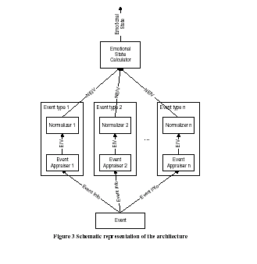

Bazzan and Bordini have developed agents with emotions who participate in an iterated prisoner’s dilemma. They developed a rule-based system based on the OCC model with the aim to create a framework in which users can easily define emotions for their agents.

Egges et al. propose to use the OCC model only for the appraisal of emotions and feed this information into a personality model they are developing. The personality model will serve as a selection criterion that indicates what and how many goals, structures and attitudes fit with the personality. They use the OCEAN model of personality (Openness, Conscientiousness, Extraversion, Agreeableness, Neuroticism). A visual front-end produces output by generating speech and facial expressions.

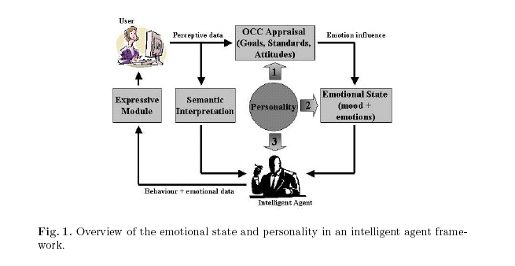

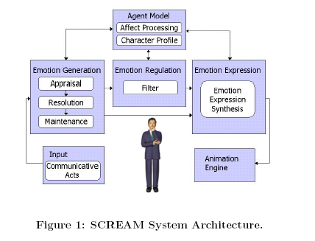
Prendinger and Ishizuka have developed an architecture called SCREAM (SCRipting Emotion-based Agent Minds) based partly on the OCC model. It contains an appraisal module, an emotion resolution module and an emotion maintenance module.

Their model takes into account the social context in which emotions are expressed or suppressed.

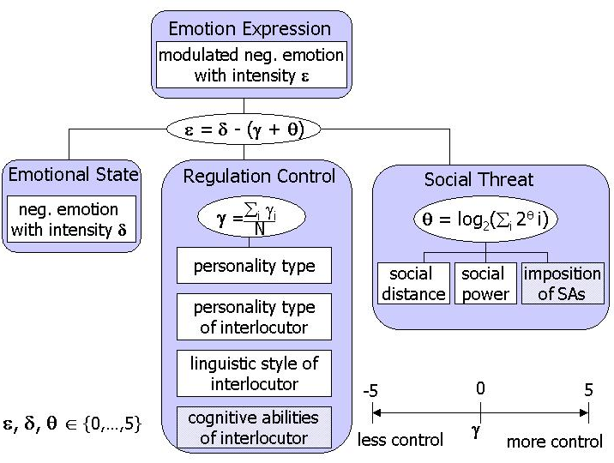

They propose to enrich a believable agent with “narrative intelligence” because humans tend to frame the behaviour of other agents into narrative. They refer expressly to the Oz project and the work of Hayes-Roth. As Sengers has pointed out:

“that artificial agents can be designed to produce narratively comprehensible behavior by
structuring their visible activity in ways that make it easy for humans to create narrative explanations of them."

Sengers' characterization is derived from narrative psychology that claims that people make sense of the behavior of other humans by structuring their visible activity into narrative (Bruner [8]). More speci¯cally, people frame the activity of other agents into story in that they try to interpret other agents' actions as intentional behavior, e.g., by attributing desires and attitudes to them. The conclusion drawn by Sengers is that animated character designers should provide characters with visible cues to support people in their attempt to generate a narrative explanation of the character's actions, and hence improve their understanding of the character's intentions.

Mourao and Paiva, the creators of EToy, have developed for their system an Affective User Model Component (AUMC), which, too, is based on the OCC taxonomy. It provides the ability to store and make inferences about the user’s affective states.

The inference motor is responsible for the kernel process in the affective user model component. This process receives information about the user’s actual perceptions, his goals, knowledge and the physical emotions / actions corresponding to the emotions or actions directly inferred from the physical interface component. The inference motor will then infer the new current emotional state for the user, given the knowledge of such information.
This module is composed by an appraisal structure that follows a rule-based approach. It has a set of if-then rules that will activate an emotion (the consequent) when a given situation (the antecedent) is verified. This appraisal can have for instance, the rule: if (agent is pleased about an event) then (agent feels happy). In this case, the appraisal must also have the rules that determine when the agent will be pleased with a given situation, for instance, if he sees a blue object, he likes blue and one of its goals is to pick the objects he likes.

The information produced by the Inference Module will be used to the updating process to update the user state model. The new inferred emotion will flow directly to the actuators.

The application the user is running will feed the system with some necessary aspects that must be considered for user’s emotional state assessment. These aspects constitute the synthetic agent’s perceptions of the application’s virtual world. The perceptions the AUMC has about the virtual world are coming from what we call the virtual sensors.

Some information passed to the affective model, from these virtual sensors, may not be relevant, at a particular instant, for the inference process. Thus, the filtering process is responsible for, according with the current situation (namely goals and knowledge), determining the relevant information about the virtual world for the inference process. The filtering mechanism is necessary in such a system, in order to increase its performance. It is important that the system does not overload the inference process with information that is not important for the realization of the task.

c) The generation of emotions

Generating emotions differs fundamentally from the simulation of emotions insofar as, in this case, the goal is to give a machine the opportunity to develop its own emotions. Emotions, in this approach, are defined as emergent properties of a system and not a set of pre-defined rules.

The task is, thus, to design a system that is able to generate its own emotions. One of the main proponents of this design-based approach is Aaron Sloman of Birmingham University. He views emotions (or affect) as control-states of an intelligent system. Sloman cites a number of factors on which a wide range of affective states depends:

- whether they are directed (e.g. craving an apple) or non-specific (e.g. general unease or
- depression),
- whether they are long-lasting or short-lived
- how fast they grow or wane in intensity
- what sorts of belief-like, desire-like and other states they include
- which parts of an architecture trigger them
- which parts of the architecture they can modulate
- whether their operation is detected by processes that monitor them
- whether they in turn can be or are suppressed.
- whether they can become dormant and then be re-awakened later,
- what sorts of external behaviours they produce,
- how they affect internal behaviours, e.g. remembering, deciding, dithering, etc.
- whether they produce second-order affective states (e.g. being ashamed of being angry),
- what sorts of conceptual resources they require.

Sloman’s architecture consists of three layers: Reactive processes, deliberative processes and meta-management processes. The current state of the architecture is called H-CogAff and is the most complex developed by his team so far. It contains numerous feedbacks and interactions between the components of the system.

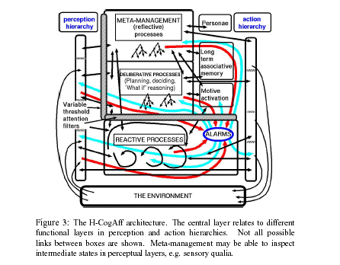
Wright, a student of Sloman’s, has developed a model he calls “computaitonal libidinal economy”. It is based on Sloman’s MINDER and adds several layers of complexity. It is interesting as a theoretical approach, but its complexity makes it very difficult to implement. His main achievement is the introduction of an internal currency by which rewards and punishments are distributed among the elements of the system.

Marvin Minsky, in his forthcoming book “The Emotion Machine”, presents a six-layered architecture of mind.

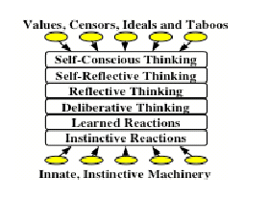
His model is similar to that of Sloman; furthermore, he adopts Wright’s internal currency. However, at the moment Minsky’s model is purely theoretical and offers no easy implementation in a machine.

I would finally like to mention Steve Grand’s “Creatures”, a commercial Artificial Life product whose inhabitants exhibit a rich emotional life. The important point is that none of that has been programmed into them. They have some basic drives and a “chemistry” of hormones; furthermore, all this information is stored in their “genes” which can recombine over the generations.
d) The expression of emotions

As pointed out above, emotional reactions do not have to be actively implemented in a machine in order to make human observers infer emotions.

Machines (as humans) can express their emotions through:

- Movement
- Speech
- Colours
- Sounds
- Written Text
- Music
- Facial expression
- etc.

Concluding remarks

As we have seen, there exists a multitude of models which try to simulate or generate emotions in a machine. Most of these models are either very limited in scope or mainly theoretical.

A number of problems still have to be solved to create an emotional machine within an interactive environment. These relate to the perception and classification of emotions as well as to the selection of appropiate responses.

Although a truly emotional machine will not be realized within the near future, within a limited and controlled domain one can implement a system that appears to be emotional to a human observer. The point of view of the development of such a system would be the user’s perception of an action.

Since a human observer does not know anything about the processes within the machine, she will judge it by its actions/expressions. It is totally irrelevant if this action is caused by simulation or is a “true” machine emotion. It might even be that “true” machine emotions differ so completely from human emotions that they would not fulfil the intended purpose.

